Networking Team Design
Server Side
Jeff, Georgi & Eric

Table of Contents
Class Diagram 2
Flow Diagrams 3
Game Logic Thread 3
Listen Process 6
Receive Process 7
Send Process 8
Pseudo-Code 8
Functions used on Game Logics main thread 8
listenSignal() 8
receiveSignal() 8
startServer() 8
stopServer() 9
Session.disconnect() 9
Session.send() 9
ServerNetworkEntity.update() 9
ServerNetworkEntity.register(session) 9
ServerNetworkEntity.unregister(session) 9
Listen Process 9
listenProcess() 9
listenSignalHandler() 10
Receive Process 10
receiveProcess() 10
Send Threads 11
sendMessage() 11

Class Diagram
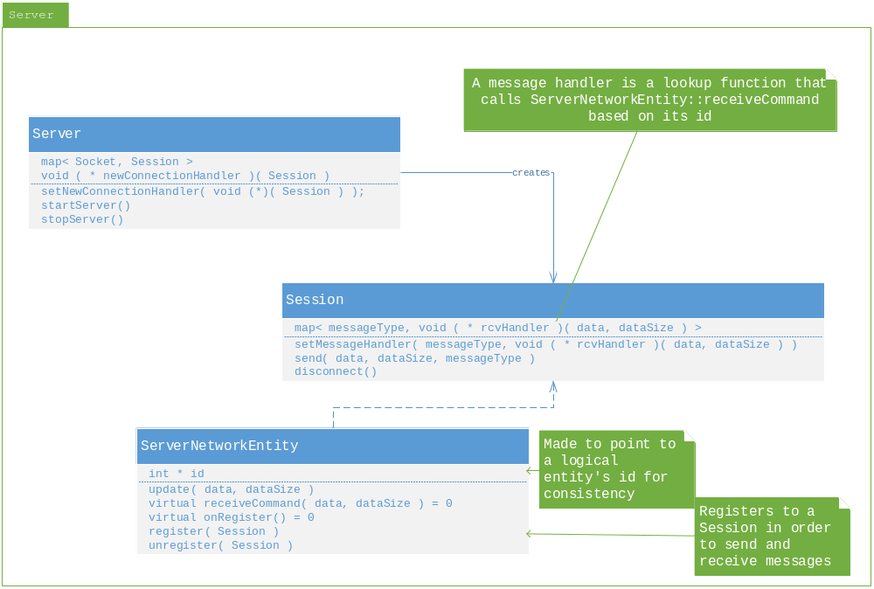

Flow Diagrams

Game Logic Thread
The networking API exposed to the game logic people are all non-blocking functions.
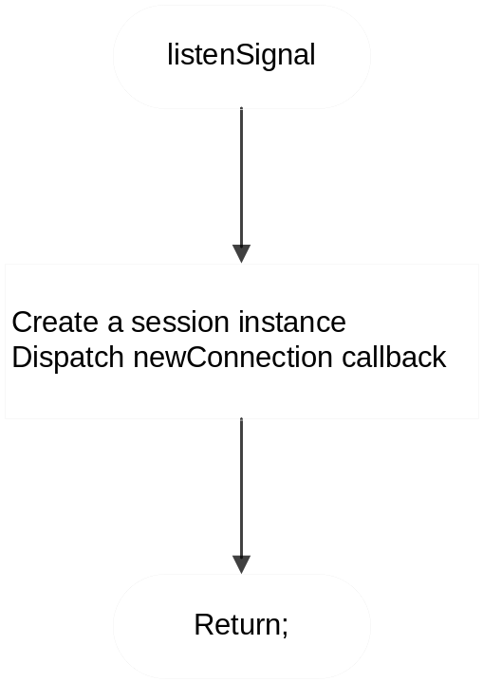 | Handles signals from the listen process.  When a signal is received from the listening process, a new session instance is created, and the newSession callback is invoked
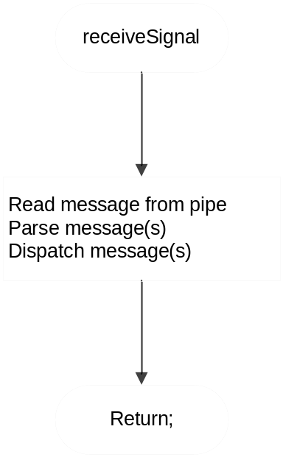 | Handles signals from the receive process.  When a signal is received from the receive process, we perform a read from the pipe, parse the message, and dispatch it through the dispatcher.
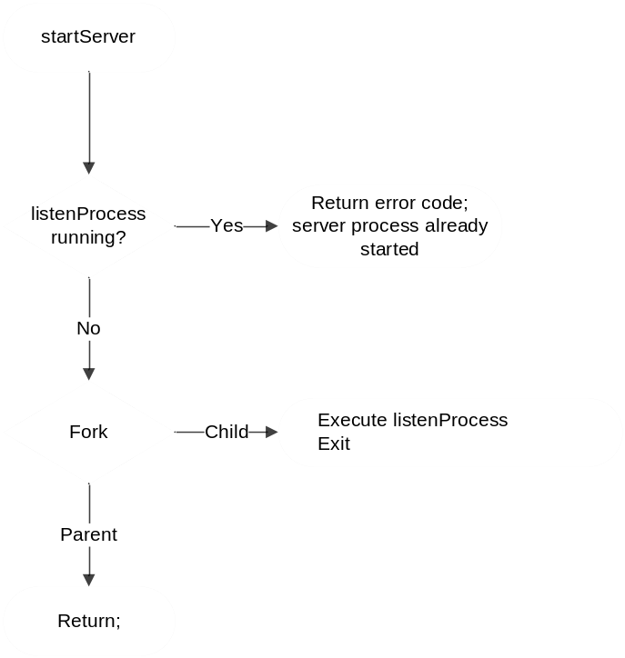 |  | The start server function. It starts the server on a separate process if it isn't already running.
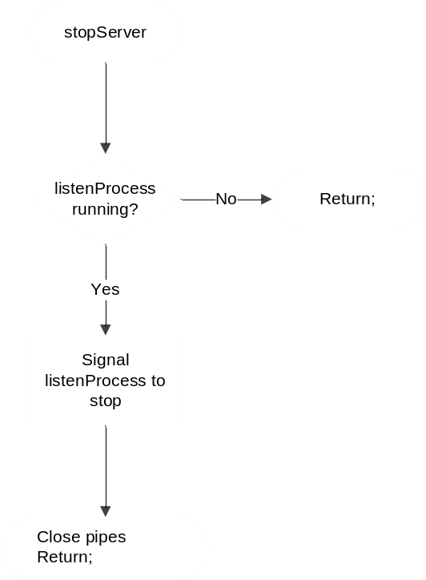 |  | Stops the server process if it is running.
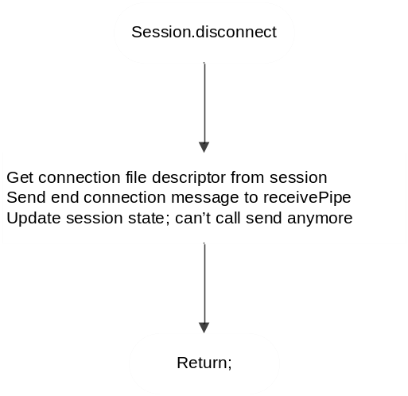 | Ends the calling session, and sends an "end connection" message to the receive process.
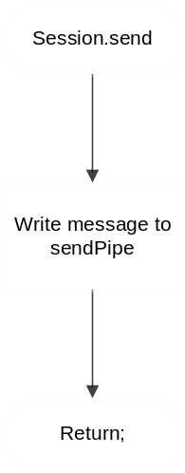 | Sends the specified data over the network.  When this function is called, it writes the data to send into a message, and sends the message to the send process.

Listen Process
The listen process is responsible for listening for new connection requests, and it informs the main thread (game logic), and receive thread of the new connections whenever a new connection is made.
This process is stopped with a signal.
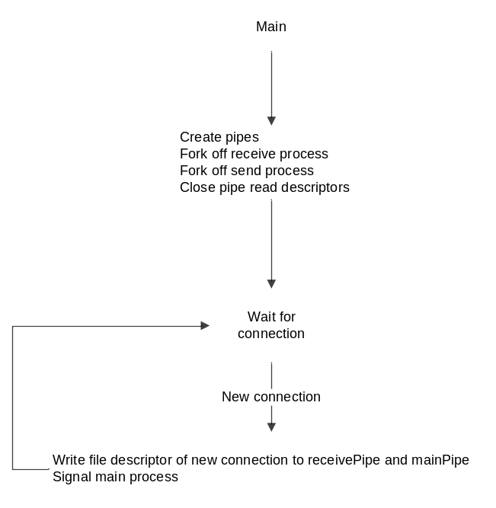 | This is the main function of the listening process.  It creates the other processes, then continuously waits for new connections
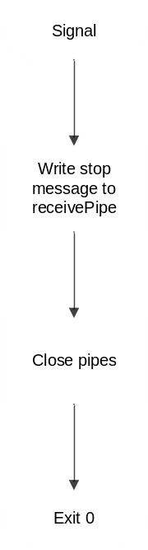 | When the listening process receives a signal, it sends messages and closes pipes as necessary to stop the receive and send processes, then exits itself.

Receive Process
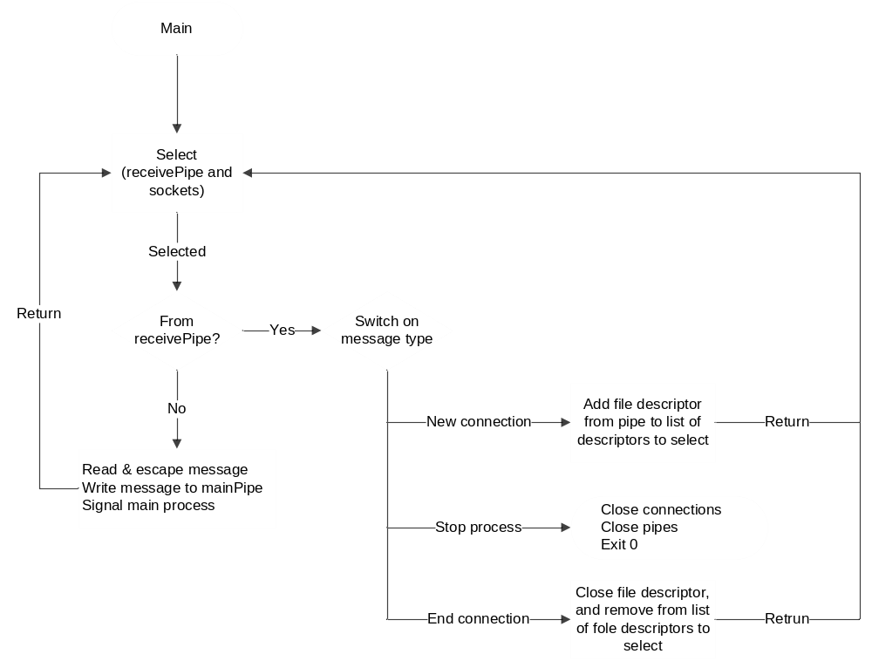
The receive process polls an array of file descriptors. The array contains a pipe for controlling the process, and the rest of the file descriptors are sockets of connected clients.
If the poll function returns a file descriptor of a socket, it adds a header to it, forwards to the main process and finally, signals the main process to notify it of the message in the pipe.
If the poll function returns the file descriptor of the control pipe, it will do one of 3 things depending on the type of control message it is:
- The message is an "add connection" message. This kind of message is sent to this process when a new client has connected, and we want to add the file descriptor of the socket to the array of sockets to poll.
- The message is an "end connection" message. This message is sent to this process when a connection terminates. The corresponding socket file descriptor is removed from the array of file descriptors to poll.
- The message is a "Stop process" message; this process closes all the file descriptors, and ends.

Send Process
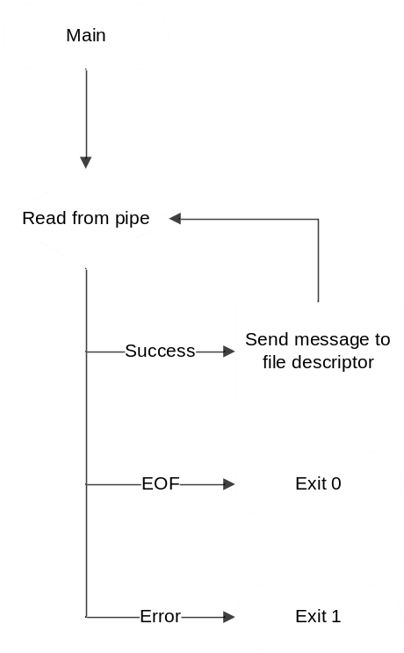 | This is the main function of the send process.  This function reads from a pipe in a loop:  - When the pipe closes, and returns EOF, then this process exits.  - When the pipe returns an error, then the process exits in error.  - When the pipe returns data, it parses the header, and sends the message out through the specified socket file descriptor, then it loops back to read more data from the pipe.

Pseudo-Code

Functions used on Game Logics main thread

listenSignal()
Create a new session instance, and pass it the socket
Add the socket, and session to our map of sessions and sockets
Server.newConnection(Session)
Return;

receiveSignal()
retrieve Session based on socket
extract destination id from message
retrieve ServerNetworkEntity based on id
call ServerNetworkEntity::receiveCommand()

startServer()
if LISTENING
return ERROR // connection process already started
if pid <- fork() fails
return ERROR
switch pid
parent:
create threads for send thread pool
child:
listenProcess()
exit 0

stopServer()
if !LISTENING
return
send signal to listen process
close pipes
return

Session.disconnect()
get socket file descriptor
write end connection message to receivePipe with the socket file descriptor
invalidate the session...set state to closed; can’t send to this session anymore

Session.send()
assign thread to sendMessage()
return

ServerNetworkEntity.update()
iterate through session set and invoke their send functions
virtual ServerNetworkEntity.receiveCommand(struct command) = 0
virtual ServerNetworkEntity.getOnRegisterUpdate() = 0

ServerNetworkEntity.register(session)
add session to set of sessions

ServerNetworkEntity.unregister(session)
remove session to set of sessions

Listen Process

listenProcess()
if create receivePipe or create mainPipe fails
return ERROR
if (rpid = fork() ) = -1)
return ERROR
else if rpid > 0
receiveProcess()
return
if (spid = fork() ) = -1)
return ERROR
else if spid > 0
sendProcess()
return
close pipe read descriptors
if !create listenSocket
kill children
return ERROR
bind listenSocket to PORT // public server port
listen()
register listenSignalHandler callback
for(;;)
if ((new_sd = accept()) != -1)
write new_sd to receivePipe
write new_sd to mainPipe
signal main process
else
Handle error somehow

listenSignalHandler()
write stop message to receivePipe
close receivePipe and mainPipe
close listenSocket
exit

Receive Process

receiveProcess()
for(;;)
if poll(receivePipe[0] and sockets) // look at poll, ppoll. you’re right, i think poll fits our needs better
if from receivePipe
switch(message type)
case newConnection:
update socket list and number
break
case stopProcess
close all receive sockets
close pipes
exit
case endConnection
close socket
remove socket from list
decrease socket count
break
else // from a socket
read and escape message
write message to mainPipe
signal main process

Send Threads

sendMessage()
write message to appropriate socket
if write fails
return ERROR

